YEAR 7 MATERIALS TECHNOLOGY

TECHNOLOGY PAST AND PRESENT

Name:___________________________ School:____________________
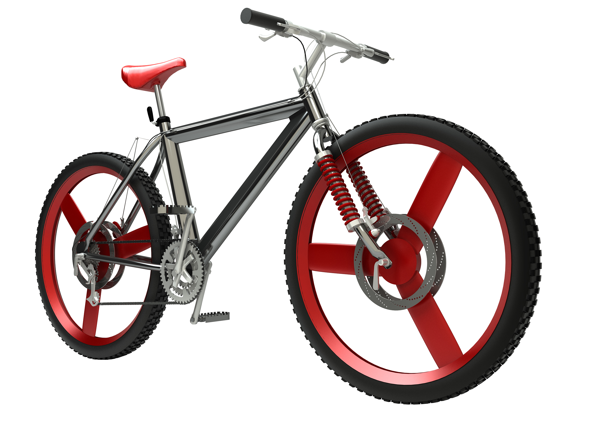
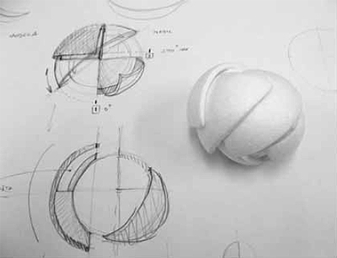

Manipulation metal fire resistant melts

Pliable

Elastic

Shiny

Colourful

Natural World prototype modelling

Made World plastic Durable

Stretches Easy to mould Insulates
PLANNING FOR SUCCESS IN TECHNOLOGY TERM 3
My goal for term 3 is

What will you do to achieve your goal?

Did you achieve your goal for the term?
Yes No
If not why was it not achieved?

_______________________________________________________________________________________

Student Signed Mrs Elder

South Otago High School Junior Technology Centre
Year 8 Soft Materials Technology Assessment
Learning Intention: Learn to understand that technology reflects both society and the environment and
increases what people can do.
Level 2 Level 3 Level 4
Nature of Technology  Characteristics of Technology | I can describe the relationship between the made, natural and social world.  I can describe how technological outcomes have changed over time and changed how people do things.  I can describe when technology has had a positive and negative impact on society and the environment. | I can describe how societal and/or environmental issues can influence what people decided to make, how they would undertake planning, the selection of resources, and how they would make and test an outcome.  I can explain why particular technological outcomes have changed over time.  I can describe examples of how technology has impacted on the social world over time.  I can describe examples of how technology has impacted on the natural world over time.  I can identify that technological knowledge is knowledge that technologists agree is useful in ensuring a successful outcome. | I can identify examples where technology has changed people's sensory perception and/or physical abilities and discuss the potential short and long term impacts of these;  I can identify examples of creative and critical thinking in Technological Practice  I can identify and categorize knowledge and skills from technology and other disciplines that have informed decisions in technological development and manufacture
Learning intention: Learn to select suitable materials to construct an outcome from.
Level 2 Level 3 Level 4
Technological  Knowledge  Products | I can describe the performance properties of different materials and say why the materials could be used for.  I can describe ways of manipulating a range of materials  I can say why materials used in particular technological products were chosen. | I can describe the properties of materials used in particular products that can be measured objectively;  I can describe the properties of materials used in particular products that can be measured subjectively;  I can describe how the properties combine to ensure the materials allow the product to be technically feasible and socially acceptable. | I can describe examples to illustrate how the manipulation of materials contributed to a product's fitness for purpose;  I can describe examples to illustrate how the transformation of materials contributed to a product's fitness for purpose;  I can describe examples to illustrate how the formulation of new materials contributed to a product's fitness for purpose;  I can communicate, using specialized language and drawings, material related details that would allow others to create a product that meets both technical and acceptability specifications.

South Otago High School Junior Technology Centre
Year 7 Materials Technology Assessment

 | Level 1 | Level 2 | Level 3
Technological Knowledge  Technological Products | I can identify materials that technological products are made from.  Identify performance properties of common materials.  Identify how the materials have been manipulated to make the product. | I can describe the performance properties of different materials and say why the materials could be used for.  I can describe ways of manipulating a range of materials  I can say why materials used in particular technological products were chosen. | I can describe the properties of materials used in particular products that can be measured objectively;  I can describe the properties of materials used in particular products that can be measured subjectively;  I can describe how the properties combine to ensure the materials allow the product to be technically feasible and socially acceptable.
Nature of Technology  Characteristics of Technology | I can identify that technology  helps to create the made world.  It involves people designing and making technological outcomes for an identified purpose.  I can identify that technological practice involves what you are making and why, planning what to do and what resources you need to make and evaluate an outcome. | I can describe the relationship between the made, natural and social world.  I can describe how technological outcomes have changed over time and changed how people do things.  I can describe when technology has had a positive and negative impact on society and the environment. | I can describe how societal and/or environmental issues can influence what people decided to make, how they would undertake planning, the selection of resources, and how they would make and test an outcome.  I can explain why particular technological Outcomes have changed over time.  I can describe examples of how technology has impacted on the social world over time.  I can describe examples of how technology has impacted on the natural world over time.  I can identify that technological knowledge is knowledge that technologists agree is useful in ensuring a successful outcome

What do you think technology is?

Can you remember the technology definition we used at the start of the year? Write it in the space below.

Natural World Made World Social World

Write the following words under the headings above.

Trees, Roads Shops, Rugby Team, Mountains, Sea, South Otago High School, Swimming Pool,

Touch Team, Plane, Cell phone, Snow, Clouds.

Technological Practice involves knowing

- What you are making and why you are making it.
- Planning what to do and what resources you need to make it.
- Making and evaluating your outcome.

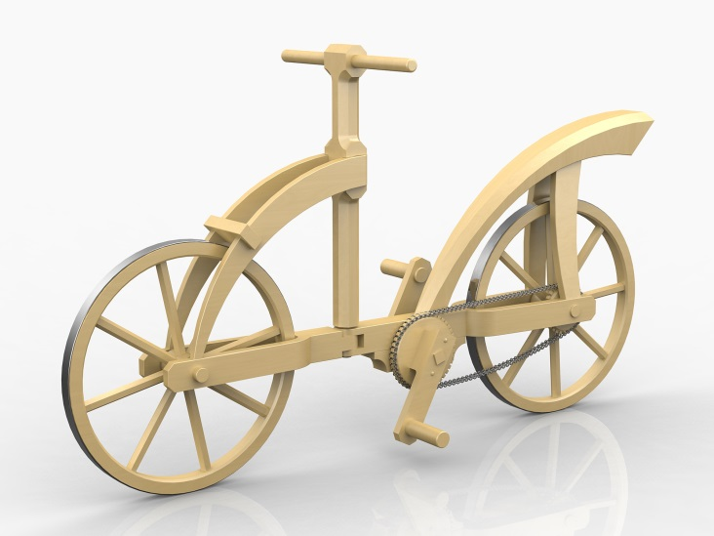
What materials were used to make Leonardo da Vinci’s bike?

How is the design of a bike different today than the painting above?

What materials would be used today to make a bike?

Do you think Leonard da Vinci’s bike is fit for the purpose? Say why or why not.

Name some attributes that you think are important for the design of a bike (an attribute is what something looks like and what it does).

PERFORMANCE PROPERTIES OF DIFFERENT MATERIALS
Choose one of the photos below and answer the questions
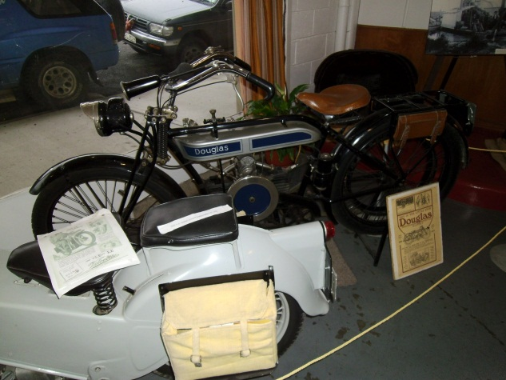
at the bottom of the sheet.

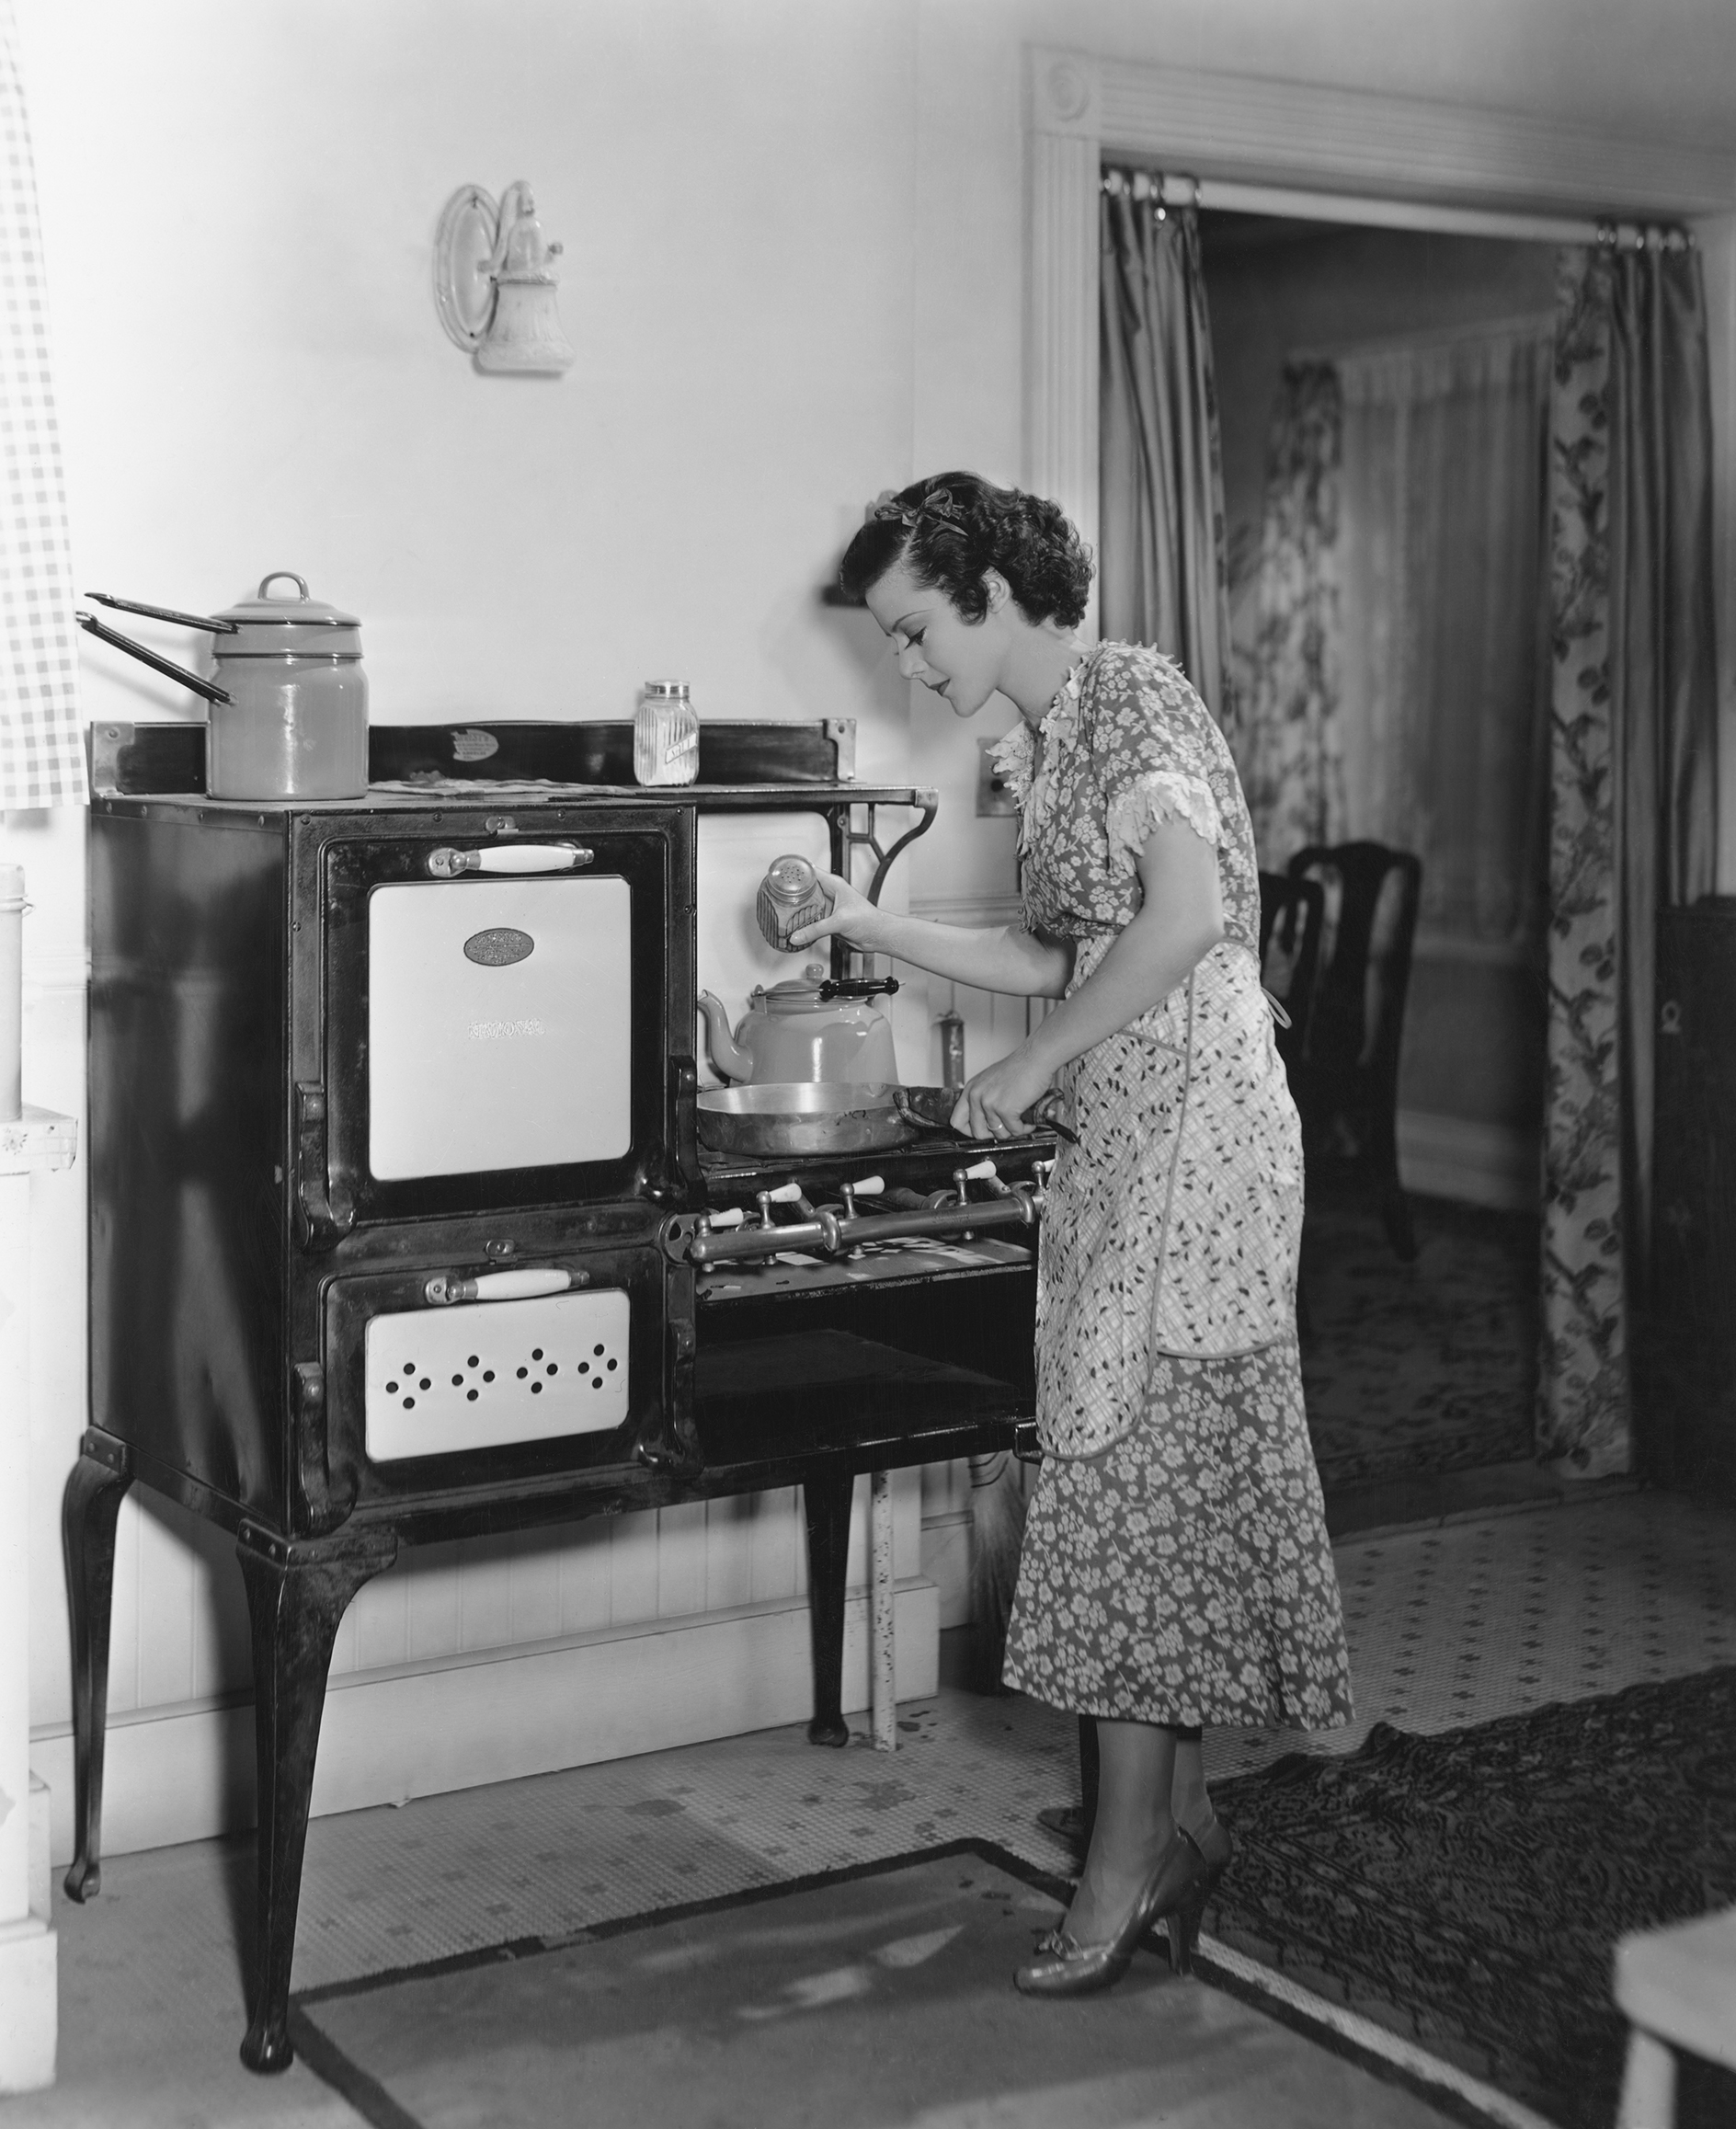
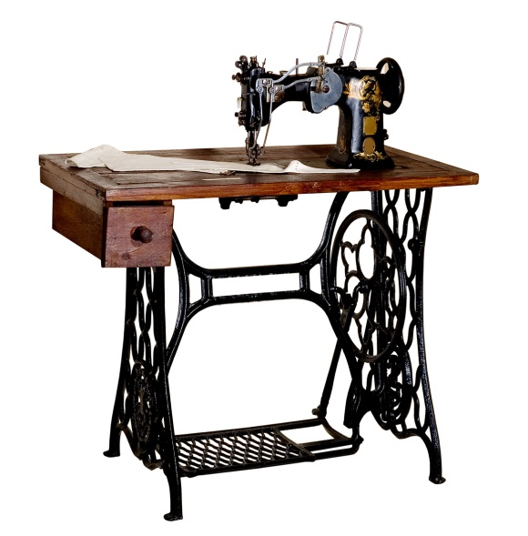

What is the object called?

What materials do you think were used to make this?

Why do you think they use these materials?

How do you think the materials they used were manipulated?
----------------------------------------------------------------------------------------------------------------------------------------------------------------------------------------------------------------------------------------------------------------------------------------------------------------------------------------------------------------------------------------------------------------------------------------------------

SOUTH OTAGO MUSEUM VISIT
Manipulation- to move, change, operate or handle something. A material can be shaped, sanded, painted, sliced, cut, sewn, moulded, spun, welded.
Sketch in the box the product you are looking at, describe how it has been manipulated to make the product. Why did they choose those materials to make the product?
Sketch How has it been manipulated? Why did they choose the materials to make the product?

PERFORMANCE PROPERTIES OF DIFFERENT MATERIALS

Strong Colourful Smooth Rough

Waterproof Melts Conductive Fire Resistant

Shrinks Soft Absorbent Durable Easy to bend

Hard Elastic Weather Resistant Stretches

Brittle Compresses Slippery Abrasive Insulating

Shiny Transparent Easy to Mould Pliable Keeps a sharp edge

CHARACTERISTICS OF TECHNOLOGY
The product that I have chosen is
_________________________________________________
Explain the how the product you chose affects people and the environment
Fill in the space below.

 | Positives | Negatives
People
The Environment
Why do you think your technological product changed over time?
_______________________________________________________________________________________________________________________________________________________________________________________________________________________________________________________________________________________________________________________________________________________________________________________

Has it changed how people do things?
_______________________________________________________________________________________________________________________________________________________________________________________________________________________________________________________________________________________________________________________________________________________________________________________

What did you find out about this material after testing and trialling it in class? The material can be ________________________________________________________________________________________________________________________________________________________

Attach the Material sample in the box above HOW WHAT WHY?
I could use my material to make______________________________________________________________________________________________________________________________________

Describe how you were able to manipulate (change ) your material.
I manipulated my material by
_______________________________________________________________________________________________________________________________________________________________________________________________________________________________________________________________________________

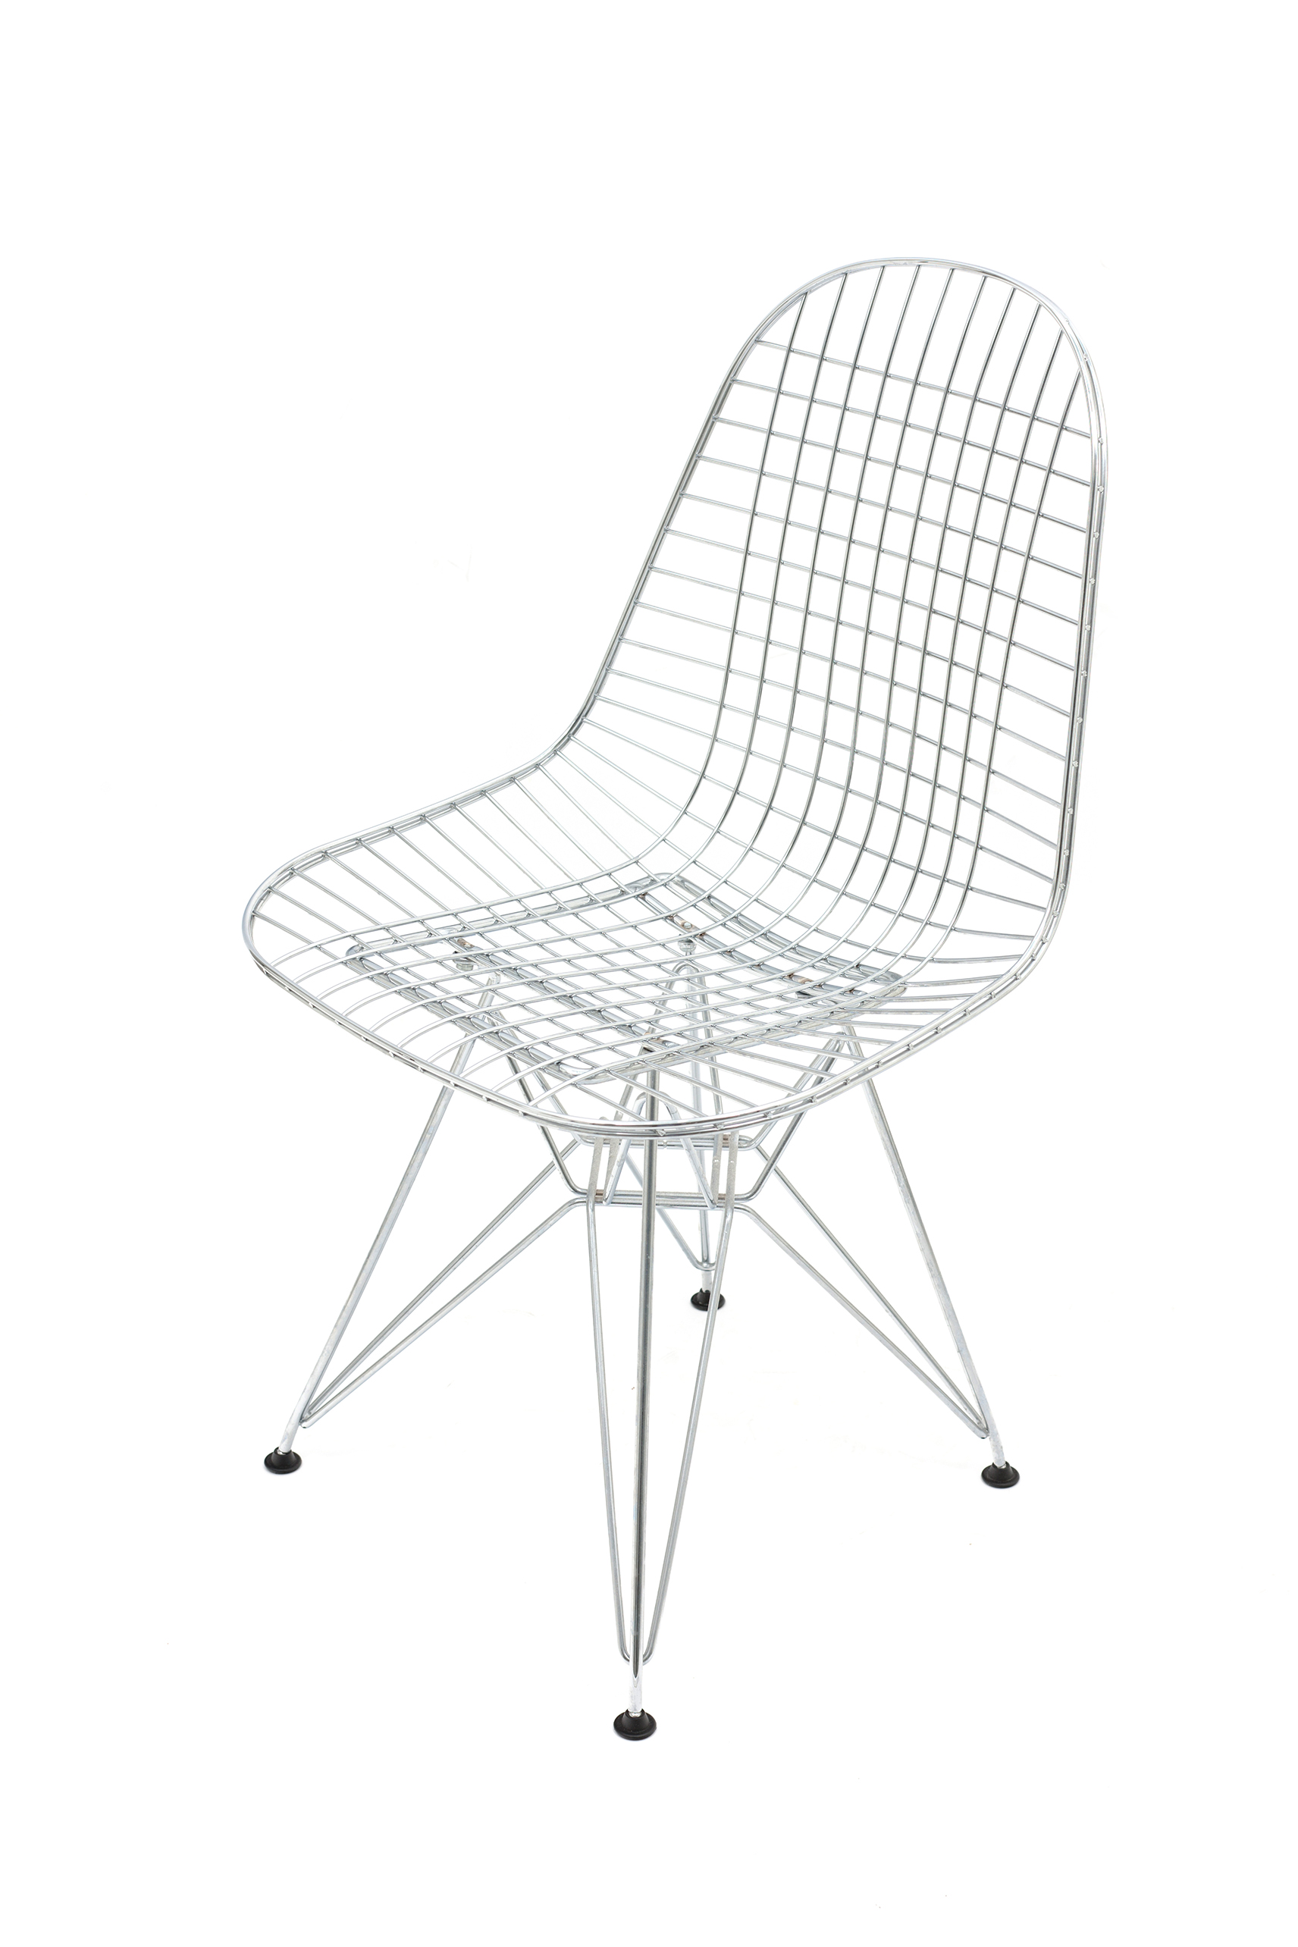

PERFORMANCE PROPERTIES OF MY MATERIAL

Write in the box below words that describe the performance properties of the material you have been testing (use the performance properties sheet to help you).

NOTES

